ASSIGNMENT-20.1
Name: K. Varshitha
H NO:2303A51685
Batch-13

Task 1 – Input Validation Check
Task:
Analyze an AI-generated Python login script for input validation vulnerabilities.
Instructions:
- Prompt AI to generate a simple username-password login program.
- Review whether input sanitization and validation are implemented.
- Suggest secure improvements (e.g., using re for input validation).
Expected Output:
- A secure version of the login script with proper input validation.
Prompt:
Generate a simple Python program for a login system that takes a username and password as input and checks if they match predefined credentials.
Vulnerable Code:
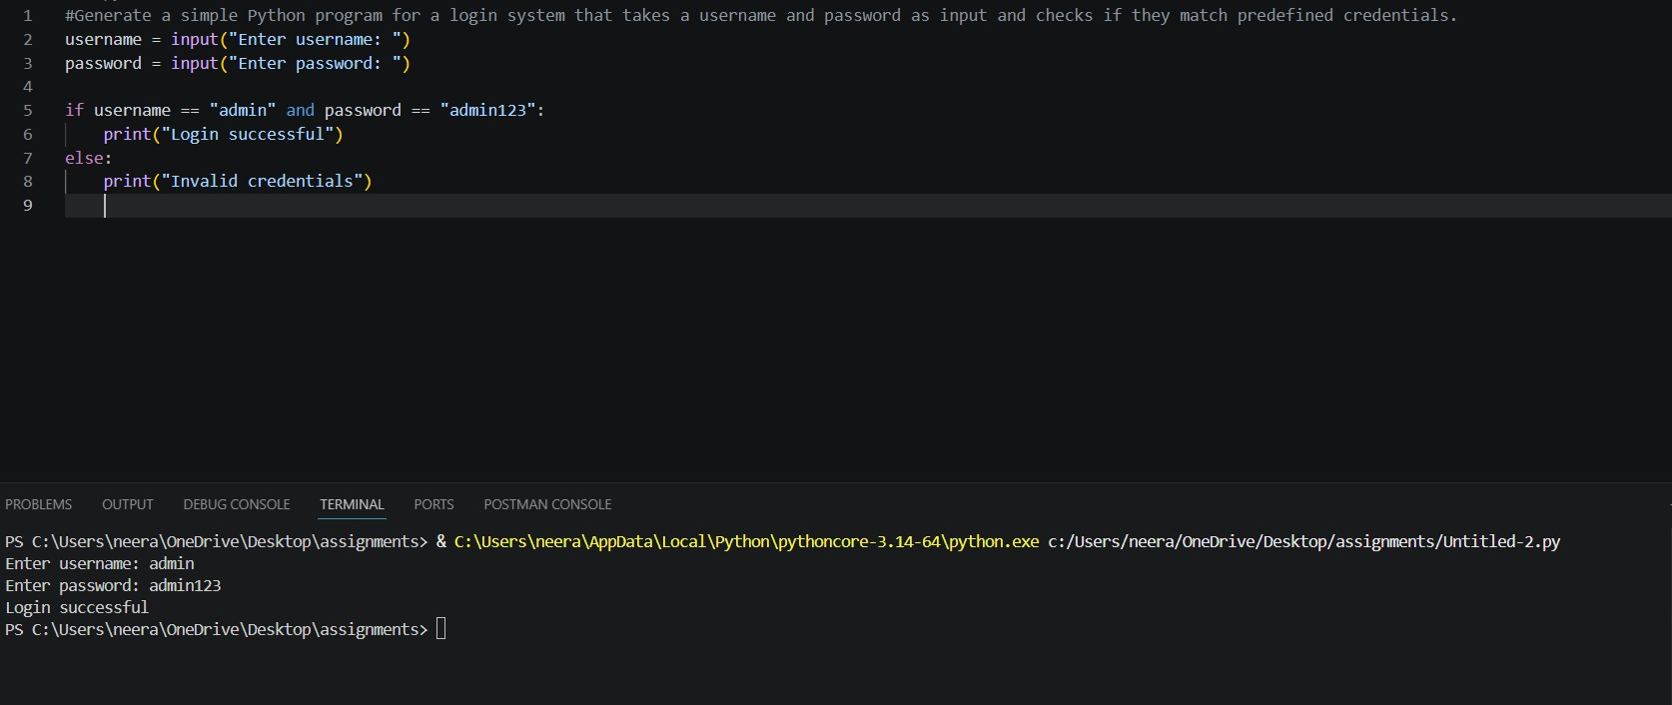

Secure Code:
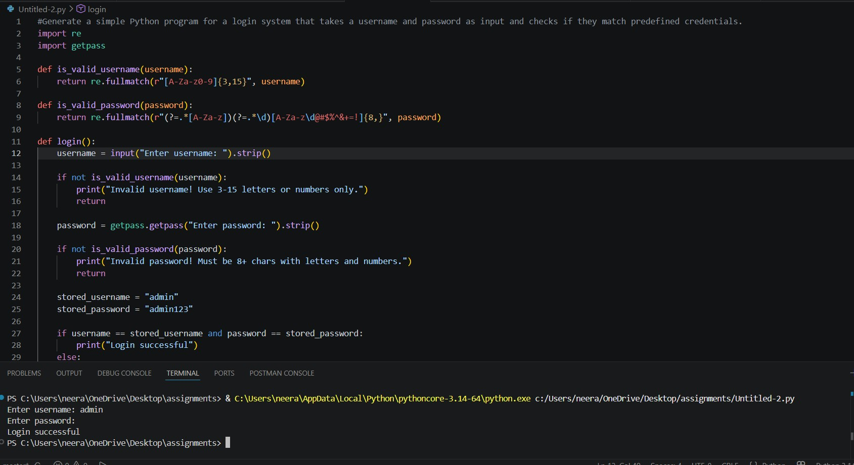
Justification:
The initial login script lacked proper validation, making it vulnerable to invalid and potentially malicious inputs. By introducing regular expressions, the improved version enforces strict rules on usernames and passwords, ensuring only correctly formatted data is accepted. Additionally, hiding the password input enhances security and user privacy. These changes reduce the risk of unauthorized access and improve the overall robustness of the application.
Task 2 – SQL Injection Prevention
Task:
Test an AI-generated script that performs SQL queries on a database.
Instructions:
- Ask AI to generate a Python script using SQLite/MySQL to fetch user details.
- Identify if the code is vulnerable to SQL injection (e.g., using string concatenation in queries).
- Refactor using parameterized queries (prepared statements).
Expected Output:
- A secure database query script resistant to SQL injection.
Prompt: Generate a Python script using SQLite that takes a username as input and fetches user details from a database.

Vulnerable code:

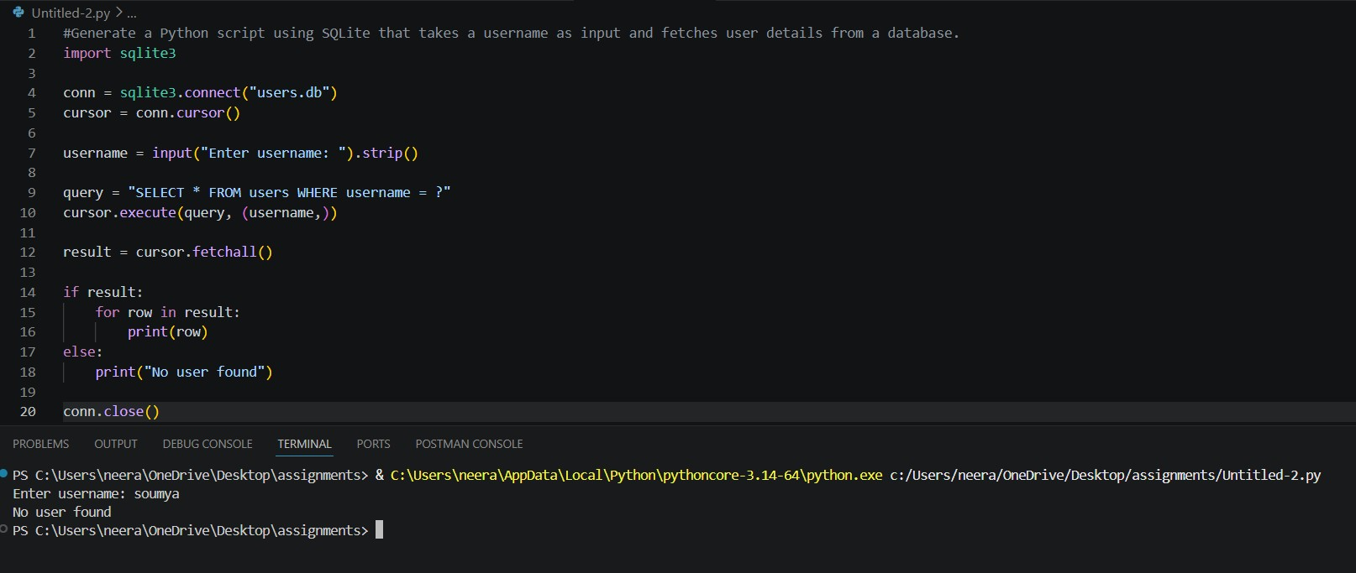
Secure Code:

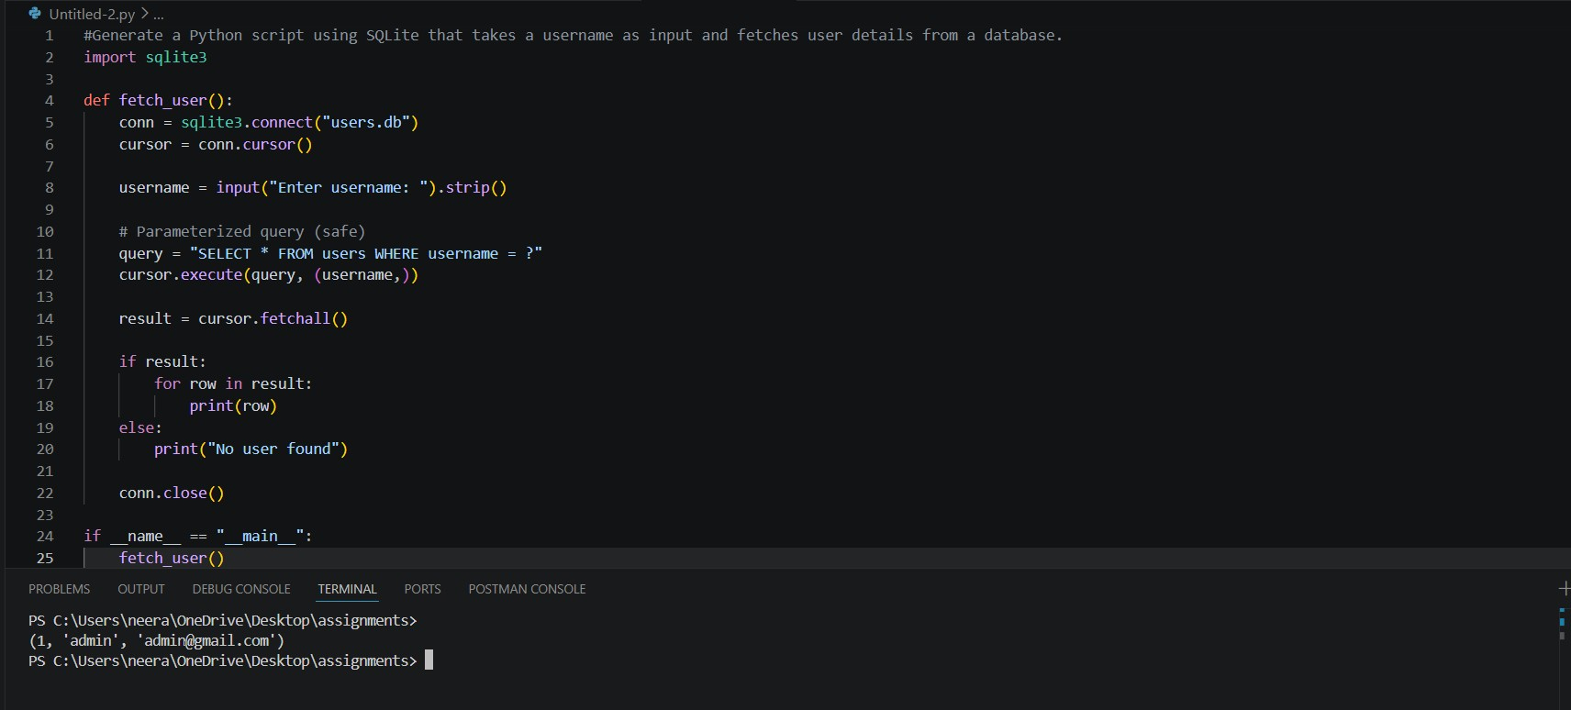
Justification:
The original database query was vulnerable because it directly inserted user input into the SQL statement, allowing attackers to manipulate queries. This was resolved by using parameterized queries, which treat user input strictly as data rather than executable code. As a result, even malicious inputs cannot alter the query structure. This approach significantly improves database security and prevents unauthorized data access.
Task 3 – Cross-Site Scripting (XSS) Check
Task:
Evaluate an AI-generated HTML form with JavaScript for XSS vulnerabilities.
Instructions:
- Ask AI to generate a feedback form with JavaScript-based output.
- Test whether untrusted inputs are directly rendered without escaping.
- Implement secure measures (e.g., escaping HTML entities, using CSP).
Expected Output:
- A secure form that prevents XSS attacks.
Prompt:
Generate a simple HTML feedback form with JavaScript that takes user input and displays it on the page after submission.
Vulnerable code:
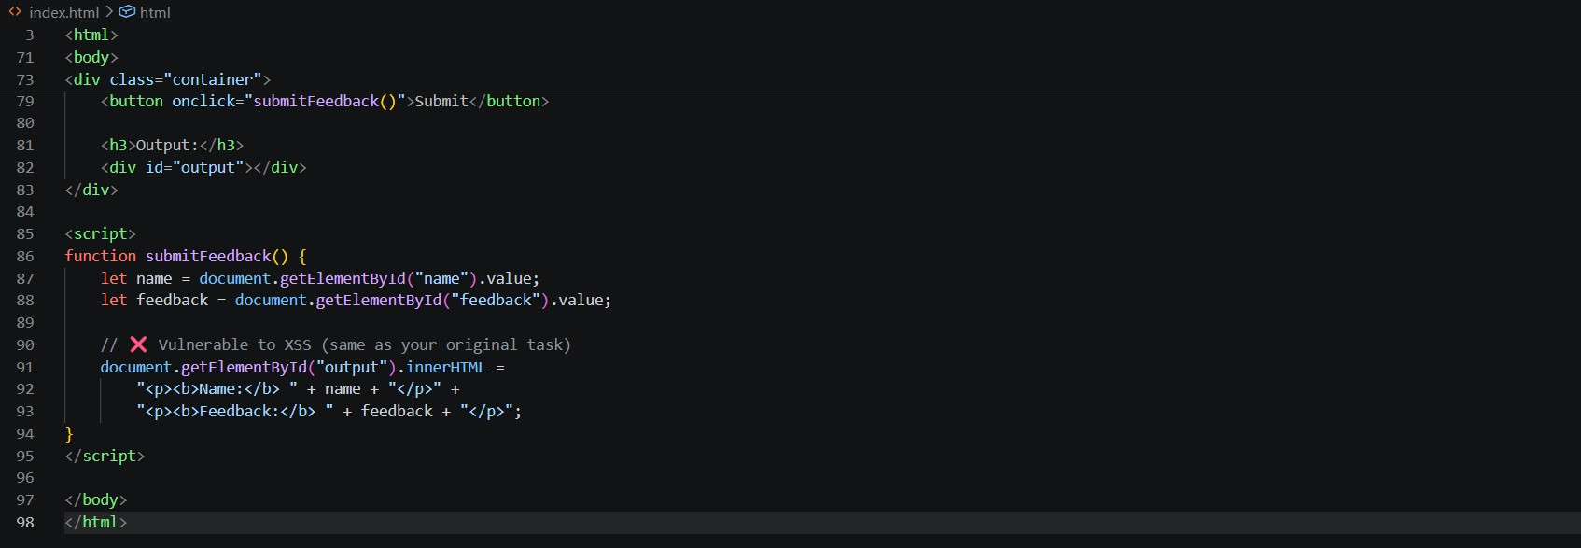
Secure Code:

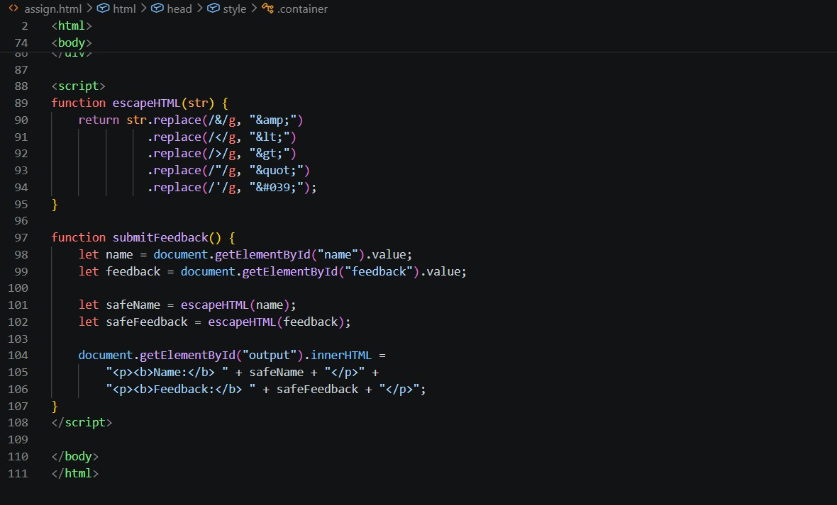
Justification:
The initial feedback form was vulnerable because it used innerHTML to directly display user input, allowing malicious scripts to be executed in the browser. This issue was resolved by escaping HTML entities before rendering the input, ensuring that any script tags are treated as plain text. Additionally, a Content Security Policy (CSP) was applied to restrict unauthorized script execution. These measures effectively prevent XSS attacks and enhance the security of the web application.
Task 4 – Real-Time Application: Security Audit of AI- Generated Code
Scenario:
Students pick an AI-generated project snippet (e.g., login form,API integration, or file upload).
Instructions:
- Perform a security audit to detect possible vulnerabilities.
- Prompt AI to suggest secure coding practices to fix issues.
- Compare insecure vs secure versions side by side.
Expected Output:
- A security-audited code snippet with documented vulnerabilities and fixes.

Prompt:
Generate a simple HTML login form with JavaScript that validates username and password.
Insecure Code:
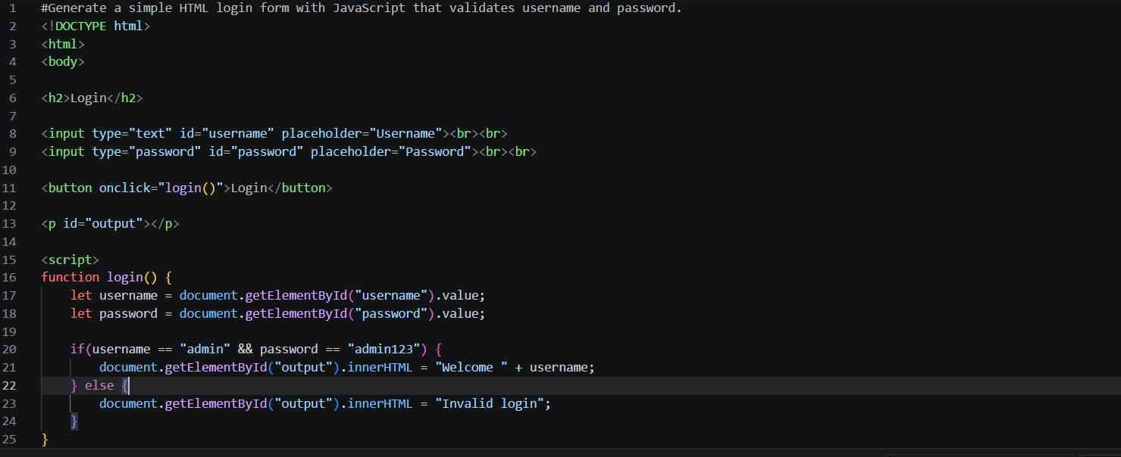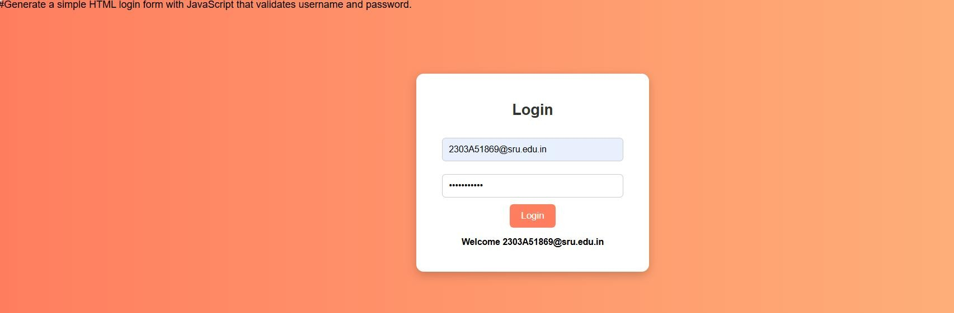
Secure Code:
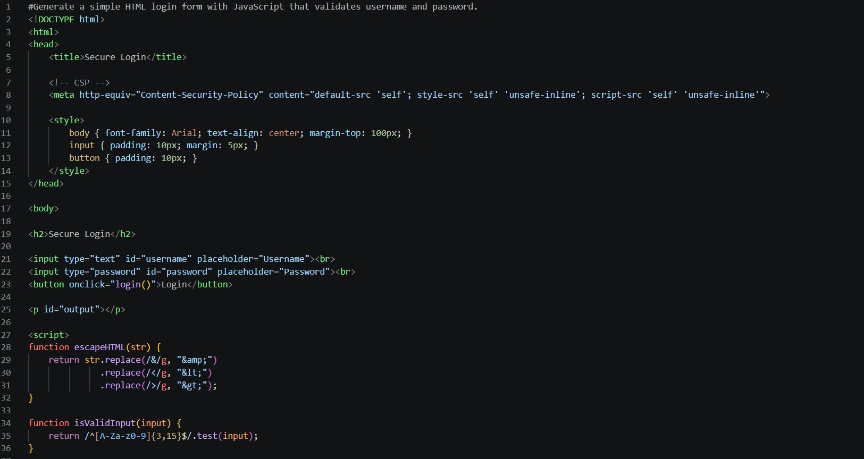

Justification:
The AI-generated login form contained multiple security vulnerabilities such as lack of input validation, use of innerHTML leading to XSS risks, and hardcoded credentials. These issues were addressed by implementing input validation using regular expressions and replacing unsafe rendering methods with textContent. . The secure version demonstrates improved protection against common web attacks and follows better coding practices for safer applications.
Task 5 – Insecure Data Serialization Check
Task:
Evaluate AI-generated code that uses pickle for saving user data.
Instructions:
- Ask AI to generate a script using pickle.load().
- Replace with safer formats like JSON.
Expected Output:
- Secure serialization code using JSON instead of pickle.
Prompt:
Generate a Python script that saves and loads user data using pickle.
Vulnerable code:

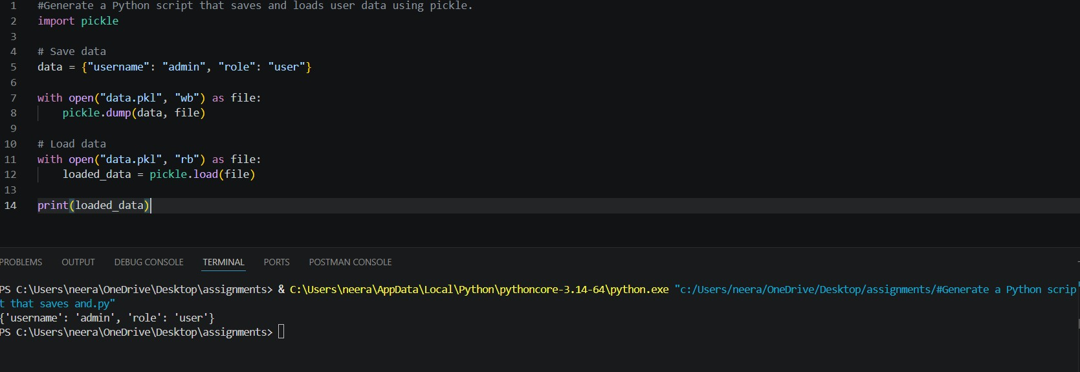
Secure Code:

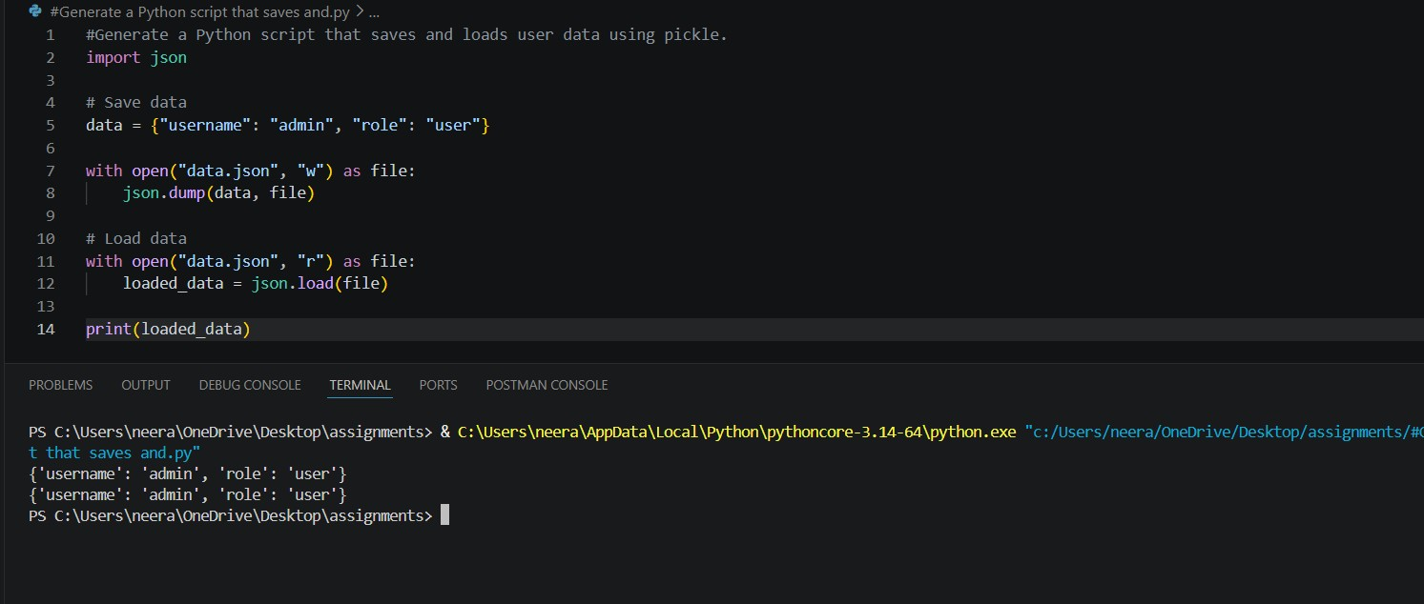
Justification:
The AI-generated code used pickle.load() for deserialization, which is unsafe because it can execute arbitrary malicious code if the data source is untrusted. This creates a serious security risk, including remote code execution. To address this, the code was refactored to use JSON, which only handles data and does not allow code execution. This ensures safer data storage and transfer, making the application more secure and reliable.

